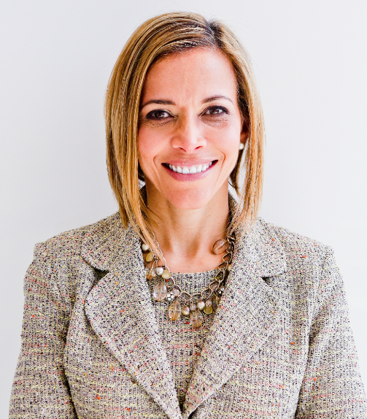 | Strategies to Develop Leadership Skills & Shift from Surviving to Thriving  with  Dr. Ginny A. Baro
Dear UNIDOS member,
​Welcome to your Training Resources! Congratulations on your commitment to taking your leadership skills to the next level.
This is your personalized, dynamic Workbook with valuable tactics to “bet on yourself” and “create opportunities,” the two strategies we discussed in our August 18th event to develop leadership skills and shift from surviving to thriving. In September and October 2022, we’ll tackle four other powerful strategies to support your growth as you become a self-led leader and continue to evolve into your full potential.
Promise yourself to set a deadline and work on these Tools. They support you to increase your motivation and focus and direct your time, energy, and efforts toward productive, meaningful activities. Prioritize working on the exercises and self-development for 15-20 minutes to complete all three tools. You’ll gain clarity about your compelling vision and goals, craft a concise elevator, and build your network and Centers of Influence diagram. Combined, you’re developing self-leadership. No one will prioritize YOU—only you can. Without this level of intention, you’ll continue to get the same results. Let’s take it up a notch!
Your private resources page will be available until December 2022 and will provide the Workbooks, presentations, and additional resources from our training: http://www.ExecutiveBound.com/unidos22.
Enjoy the journey and remember to contribute to and lean on your UNIDOS community members for support. I’m only an email away.
Live with purpose, live with joy!
Coach Ginny
DR. GINNY A. BARO, CEO, ExecutiveBound™

Workbook Table of Contents

1. YOUR COMPELLLING VISION & GOALS 3
2. YOUR ELEVATOR PITCH 4
3. YOUR CENTERS OF INFLUENCE DIAGRAM 5

THIS WORKBOOK BELONGS TO:
Name: |  | Date:

1. YOUR COMPELLLING VISION & GOALS
To bet on yourself, let’s identify your compelling vision and goals for the next 12 months. This vision and specific goals will help you feel inspired, energized, and motivated to pursue activities that will move the needle in your leadership and personal life. After you identify “what happened?” ask yourself, why is that important to me? Try inviting a trusted peer in this training to do these exercises together. Find a quiet, private place, and let’s do this.
- Imagine you and I are meeting 12 months from now, and you’ve had a WILDLY SUCCESSFUL YEAR—the best of your career yet! What happened? Share with me in detail what you achieved, how you showed up, how you felt, what you and the team accomplished, what happened in your personal life, the impacts you had, and how you contributed. Write it down in the past tense, as if these already happened! (because they have! 😉)

- What happened 1
- What happened 2
- Keep asking yourself what else happened and writing until you can’t think of anything else.
- Etc. For example, I got promoted to the next role and now earn 15% more; I completed xyz initiative successfully and the team was re-energized; I set boundaries and ended work by 6 PM most weekdays; I spent quality time with the family with all devices “off.” I learned about derivatives now support my team by answering related questions, etc.
- For the list of goals you created in answer #1, please describe briefly Why these goals are important to you. The ones that don’t have a significant enough “Why,” cross them off. The rest remain on your list of compelling goals for the next 12 months.

- Why is the goal important 1
- Why is the goal important 2
- Etc. For example, by reaching the next role, I can contribute at a more strategic level and influence where we go as a team. The extra money can help the family save for college and enjoy a family vacation during the summer.

- What did you notice as you answered these questions? Reflections are valuable to increase your self-awareness, one of the components of emotional intelligence. How easy or challenging was it for you?

2. YOUR ELEVATOR PITCH
When you are networking, attending a conference, joining a new group, or connecting with someone through work, how helpful would it be to have your elevator pitch in your back pocket? It is a 1 – 2-minute introduction to you that lets others know what you do, the value you add, and what you enjoy about your role. As you share it, you promote your personal brand, expertise, and create potential opportunities for collaborations and growth. That’s what we’re going to do next. Enjoy the journey!
- Who are you?
- What is your Why?
- What’s your expertise & who do you help?
- What impact do you have (a recent win)?
- What are you about outside of work?
After crafting your pitch below, read it out loud, and tweak it, so it sounds natural. Then, remember the start of each sentence (in bold in my example below) to use as a “trigger” to remind you what’s next as you practice your pitch with trusted friends. The color legend below points to each component of the pitch.
___ <greeting>! My name is ___, and I’m ___<title now> at <company name or dpt>. I have over ___ years of experience in the ___ industry/ies. I’m passionate about / I care about / My Why today is ___ <your Why>. My expertise is in / I specialize in ___<what you get paid to do, your superpowers, and who you do it for>. I ___ <impact you have/had>. On my spare time / When I’m not working, I enjoy ____. ____ <closing remark>. (It’s a pleasure to be here, to meet you, to be your guest, etc.)
Here’s my example:
“Hi, my name is Dr. Ginny Baro. I’m an international transformational speaker, leadership coach, career strategies, and #1 bestselling author. I have over 25 years of experience in the financial services and technology industries. My Why today is to fulfil my full potential and to help my son Kyle and clients achieve theirs. I specialize in delivering keynotes, coaching and leadership training programs for organizations, ERGs and Fortune 500 companies to help leaders drive business growth and high-performing teams without burning out. In 2020, I created the Fearless Leadership Mastermind program, which has helped female leaders in STEM fields and financial services advance within their companies. So far, we’ve graduated five cohorts! When I’m not working, which is most of the time , I enjoy hiking, biking, meditating, traveling, and spending time with my teenage son, family, and friends. It’s a pleasure to be here.”

- What did you notice as you crafted your elevator pitch? What was easy or challenging? How willing are you to practice this elevator pitch with trusted friends? As you do, come back to it and tweak it.

3. YOUR CENTERS OF INFLUENCE DIAGRAM
Use this tool to identify your “Centers of Influence” in your professional world. You will be creating action steps to engage with them intentionally. The relationships you nurture:
- Help you promote your goals and personal brand
- Enhance your influence, impact, and well-being
- Contribute to your professional growth (e.g., new roles, mentors, sponsors, new clients)
- Increase your sense of connection and belonging—a human need
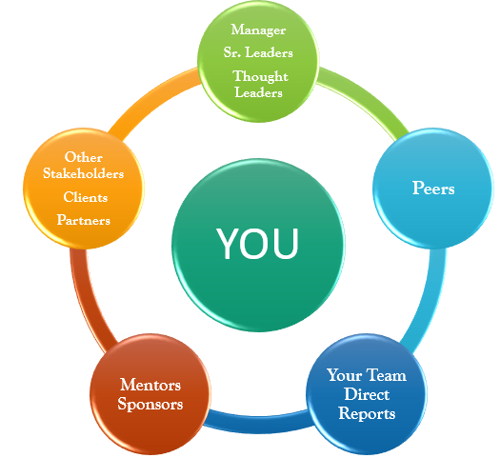
- Using the above diagram as a guide, use the next page to draw your personalized Centers of Influence diagram using the names in each circle.
Manager, Sr. Leaders, Thought Leaders | Include your manager and other senior leaders in the organization connected to your function or who you can learn from about the business, how it runs, the vision, etc.
Peers | Who are your peers within your team or those in other departments with whom you interact? Having them in your corner is meaningful.
Your Team | Who are your direct reports, or others significant stakeholders at this level of the organization who support your team? (e.g., any matric reporting teams)
Mentors / Sponsors | Who are your mentors? They serve as advisors; you trust their guidance and direction, and they can make introductions to others in the company or industry, for example. Who are your sponsors? These senior leaders can assign you an initiative, advocate for your promotion into a new role, and make it happen.
Other Stakeholders | List any critical people who are influencers in the organization or outside who interface with your role. They can be your advocates or promote your good work to others based on how they know you.

Draw your Centers of Influence diagram below:

- What did you notice as you built your diagram?
- Did you find any “gaps” in one or more areas? Which ones?
- What ideas come to mind when considering connecting with the people on your diagram? Jot them down here.
- Who do you know who can support you in developing those relationships?
- Pick one or two people to connect with weekly, monthly, or quarterly.
- Mark your calendar to reach out to them and set up a 15-minute live or cyber-coffee or tea. Slow and steady wins the race.

JOIN OUR COMMUNITY TO GAIN VALUABLE resources, strategies, AND TOOLS to help you REACH YOUR FULL POTENTIAL AND next level IN CAREER AND LIFE at www.executivebound.com
ABOUT DR. GINNY A. BARO, PHD, MBA, MS, CPC, CEO, FOUNDER AT EXECUTIVEBOUND

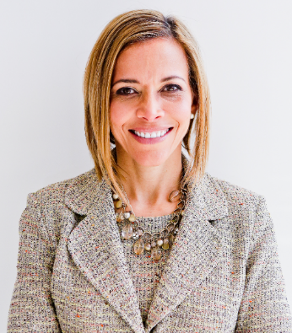  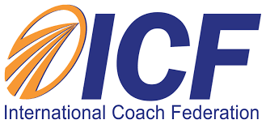  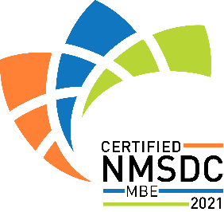 | Dr. Ginny Baro immigrated to the U.S. at age 14 with nothing more than a dream. Today, she is an award-winning international transformational speaker & leadership coach, career strategist, and #1 bestselling author of Healing Leadership and Fearless Women at Work. Named one of the Top 100 Global Thought Leaders, Dr. Baro has successfully delivered leadership training and coaching programs for Fortune 500 companies and keynotes impacting global audiences. She has been a leadership coach for McKinsey&Company's Hispanic/Latino Executive Leadership Program since 2021.  In 2020, Dr. Baro created the Fearless Leadership Mastermind™. Since then, the program has successfully helped talented female leaders in STEM fields, financial services, and Fortune 500 companies gain critical leadership skills to lead, engage, influence their teams, and advance in their roles. How? By design, it strategically leverages experiential, virtual mastermind circles within cohorts of up to 10 talented female peers for six months, executive group and individual coaching, mobile-friendly leadership training modules, personalized tools and assessments, accountability, community, and ongoing support for 12 months total.  She earned a Ph.D. in Information Systems, an MS in Computer Science, an MBA in Management, and a BA in Computer Science and Economics. She is a Certified Professional Coach (CPC) accredited by the International Coach Federation and is fluent in Spanish. To connect and learn more, please visit www.executivebound.com.

