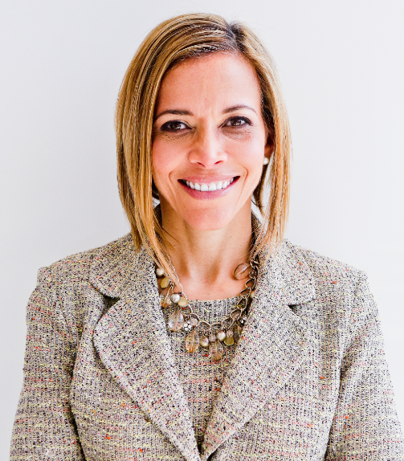 | Develop Your Value & Skills for The Next Level in a Hybrid Workplace  with  Dr. Ginny A. Baro
Dear Synergy / Adelante leader, (sometimes in business and definitely in your own life)
​Welcome to your Training Resources! Congratulations on your commitment to taking your value and skills to the next level, especially in a hybrid environment.
This is your dynamic Workbook to complement our training on October 4, 2022. If you missed the live training, as a reference, please download the presentation’s PDF and review what we covered.
No one else can do these exercises for you. You are empowered to prioritize working on them and focus on your professional development. Book yourself for 15 – 20 minutes at a time to work on the tools. You’ll gain clarity and understand your Unique Value Proposition (UVP), craft an engaging elevator pitch, build your Centers of Influence diagram, and create a realistic 12-month Action Plan to engage your network and execute toward meaningful goals.
Use your Resources page until December 2022: http://www.ExecutiveBound.com/ab
Enjoy the journey, and remember to contribute and lean on your community of ERG peers for support. We’re only an email away.
Live with purpose, live with joy!
Coach Ginny
DR. GINNY A. BARO, CEO, ExecutiveBound®

Workbook Table of Contents

1. YOUR UNIQUE VALUE PROPOSITION (UVP) 3
2. YOUR CENTERS OF INFLUENCE DIAGRAM 7
3. YOUR GOALS & ACTION PLAN 9

THIS WORKBOOK BELONGS TO:
Name: |  | Date:

YOUR UNIQUE VALUE PROPOSITION (UVP)

Your Unique Value proposition (UVP) is at the core of your personal brand. It distinguishes you from everyone else who presumably performs a similar role as you. It is a combination of these three components:
1. Your "Why," what is meaningful to you; 2. Your Superpowers--what you are great at and love; and 3. Your marketable skills, what you get paid to do.
The combination of these three components makes you as unique as a fingerprint. Knowing your UVP will help you: 1) boost your confidence & remove self-doubt, 2) position yourself to add the most value, 3) guide career and life decisions, 4) Influence and collaborate with your network and Centers of Influence. Let’s get to it and identify your UVP today.

DISCOVERING YOUR “WHY”

- Option 1: What do you live for? Be honest with yourself, explore this question by writing down your “gut” answer. This is for you, don’t hold back. What you live for is one version of your “Why” today.

- What gets in the way of what you live for? Answering this question will pin-point what to look at closer to remove/reduce to bring your closer to living more aligned with your Why.

Option 2: Let’s play a game! I’m going to ask you the same question multiple times, and each time we’re going to go deeper into your Why today. Invite a trusted peer in this training to do this exercise together. Find a quiet, private place, and let’s do this!
Why do you want to be successful in life? Answer succinctly.
Answer.

- Why is answer above important to you? Answer succinctly.

Answer #1

- Why is answer #1 important to you? Answer succinctly.

Answer #2

- Why is answer #2 important to you? Answer succinctly.

Answer #3

- Why is answer 3 important to you? Answer succinctly.

Answer #4

- Why is answer #4 important to you? Answer succinctly.

Answer #5

- Why is answer #5 important to you? Answer succinctly.

Answer #6

- Why is answer #6 important to you? Answer succinctly.

Answer #7
Write a Why statement using your answer to #7:
My Why today is Answer #7.
What did you notice about where you started with your first answer for Option 1 & 2 and where you ended up with Answer #7, in Option 2? What’s the difference, if any? Which of the answers in the two options feels most aligned with your Why today?

EXTRACTING YOUR SUPERPOWERS

- List 5 attributes—things you do very well, you are great at these, and may do them effortlessly. You may also ask trusted friends to share 5 words to describe you (these will most likely include “superpowers.”
- One
- Two
- Three
- Four
- Five

- In your role or leadership, list 3 activities / functions / value you provide / things you do that make you the happiest and you would never outsource.
- One
- Two
- Three

PINPOINTING YOUR MARKETABLE SKILLS

- List 5 specific skills you’ve developed, earn you money, and make you successful in your role and leadership. Focus on the ones you enjoy the most as these are the ones who energize you and would bring you the most fulfilment as you continue to advance.

- One
- Two
- Three
- Four
- Five

- What themes did you discover about yourself while working on your UVP?

Answer.

BONUS: CRAFTING YOUR ELEVATOR PITCH

- How would it serve you to have your ELEVATOR PITCH in your back-pocket? It is a 1 – 2-minute introduction to you that lets others know who you are and your Unique Value Proposition. Use it when networking, attending a conference, joining a new group, connecting with a new colleague at work, etc. As you share it, you promote your personal brand, expertise, and create potential opportunities for collaborations and growth. That’s what we’re going to do next. Have fun with it!

- Who are you?
- What is your Why?
- What’s your expertise & who do you help?
- What impact do you have (a recent win)?
- What are you about outside of work?

After crafting your pitch below, remove the shading, read it out loud, and tweak it, so it sounds natural. Then, remember the start of each sentence (in bold in my example below) to use as a “trigger” to remind you what’s next as you practice your pitch with trusted friends. The color legend below points to each component of the pitch.
___ <greeting>! My name is ___, and I’m ___<title now> at <company name or dpt>. I have over ___ years of experience in the ___ industry/ies. I’m passionate about / I care about / My Why today is ___ <your Why>. My expertise is in / I specialize in ___<your top marketable skills, your superpowers, and who you do it for>. I ___ <impact you have/had>. On my spare time / When I’m not working, I enjoy ____. ____ <closing remark>. (It’s a pleasure to be here, to meet you, to be your guest, etc.)
Here’s my example:
“Hi, my name is Dr. Ginny Baro. I’m an international transformational speaker, leadership coach, career strategies, and #1 bestselling author. I have over 25 years of experience in the financial services and technology industries. My Why today is to fulfil my full potential and to help my son Kyle and clients achieve theirs. I specialize in developing leaders by delivering keynotes, coaching and leadership training programs for organizations, ERGs and Fortune 500 companies. In 2020, I created the Fearless Leadership Mastermind program and graduated five cohorts so far! When I’m not working , I enjoy hiking, biking, meditating, traveling, and spending time with loved ones, especially my teenage son, Kyle. It’s a pleasure to be here.”

- What did you notice as you crafted your elevator pitch? What was easy or challenging? How willing are you to practice this elevator pitch with trusted friends? As you do, come back to it and tweak it. You may notice that you inject transition phrases between sentences to make it more “conversational.” Have fun experimenting with it!

2. YOUR CENTERS OF INFLUENCE DIAGRAM
Use this tool to identify your “Centers of Influence” in your professional world. Engage with them proactively by creating action steps in your Action Plan and connecting with them periodically and intentionally. Shift from being “transactional” to being “relational” and you’ll expand your network of allies and advocates. The relationships you build nurture:
- Help you promote your goals and personal brand
- Enhance your influence, impact, and well-being
- Contribute to your professional growth (i.e., new roles, mentors, sponsors, new clients)
- Increase your sense of connection and belonging—a human need
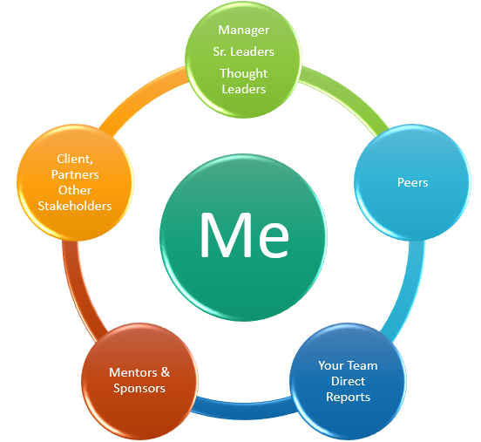
- Using the above diagram as a guide, use the next page to draw your personalized Centers of Influence diagram using the names or person’s initials that belong in each circle.
Manager, Sr. Leaders, Thought Leaders | Include your manager and other senior leaders in the organization connected to your function or who you can learn from about the business, how it runs, the vision, etc.
Peers | Who are your peers within your team or those in other departments with whom you interact? Having them in your corner is meaningful.
Your Team | Who are your direct reports, or others significant stakeholders at this level of the organization who support your team? (e.g., any matrix reporting teams)
Mentors / Sponsors | Who are your mentors? They serve as advisors; you trust their guidance and direction, and they can make introductions to others in the company or industry, for example. Who are your sponsors? These senior leaders can assign you an initiative, advocate for your promotion into a new role, and make it happen.
Other Stakeholders | List any critical people who are influencers in the organization or outside who interface with your role. They can be your advocates or promote your good work to others based on how they know you.

Draw your Centers of Influence diagram below:

- What did you notice as you built your diagram?
- Did you find any “gaps” in one or more areas? Which ones?
- How healthy are your sponsor & mentor relationships? Who do you admire / appreciate as a leader / are curious about?
- What ideas come to mind when considering connecting with the people on your diagram? Jot them down here.
- Who do you know who can support you in developing those relationships?
- Pick one or two people to connect with weekly, monthly, or quarterly.
- Mark your calendar to reach out to them and set up a 15-minute live or cyber-coffee or tea. Slow and steady wins the race. Be fearless (act despite the fear).

3. YOUR GOALS & ACTION PLAN
Let’s identify your compelling vision and goals for the next 12 months to execute and gain momentum. This vision, specific goals, and action plan will help you feel inspired, energized, and motivated to pursue activities that will move the needle in your leadership and personal life. Try inviting a trusted peer in this training or a growth-minded friend to do these exercises together. Find a quiet, private place or virtual session, and let’s do this.
- Imagine you and I are meeting 12 months from now, and you’ve had a WILDLY SUCCESSFUL YEAR—the best of your career yet! What happened? Share in detail what you achieved, how you showed up, how you felt, what you and the team accomplished, what happened in your personal life, the impacts you had, and how you contributed. Write it down in the past tense, as if these already happened! (because they have! 😉)

- What happened 1
- What happened 2
- Keep asking, what else happened, and writing until you can’t think of anything else.
- Etc. For example, I got promoted to the next role of ___ and now earn 15% more; I completed xyz initiative successfully and the team was re-energized; I set boundaries and ended work by 6 PM most weekdays; I spent quality time with the family with all devices “off.” I learned about derivatives now support my team by answering related questions, etc.
- For the list of goals you created in answer #1, please describe briefly Why these goals are meaningful to you. The ones that don’t have a significant enough “Why,” cross them off. The rest remain on your list of compelling goals for the next 12 months.

- Why is goal 1 important?
- Why is goal 2 important?
- Etc. For example, by getting promoted to ___, I can contribute strategically and influence where we go as a team. The extra compensation can help the family save for college and enjoy a family vacation during the summer. I will be growing as an expert in my field, etc.
- What did you notice as you answered these questions? Reflections are valuable to increase your self-awareness, one of the components of emotional intelligence. How easy or challenging was it for you?

- Using the goals that made the cut from question #2, create your 12-month Action Plan by filing in the table below. Set realistic expectations—biting off too much or selecting timelines you cannot commit to could sabotage your efforts. Imagine how great you’ll feel when you achieve these goals and if you do not achieve them—this approach attaches an “emotion” to each one. This Action Plan is dynamic—review it, tweak it, and track your progress along the way. Surround yourself with people who will encourage and support you if you feel stuck. Add rows as needed.
GOAL / DESIRED RESULT / OUTCOME | PURPOSE, WHY IS THIS IMPORTANT?  FUEL IN YOUR TANK | ACTIONS & ACTIVITIES TO PURSUE IT  BREAK IT DONW | COMPLETION TIMEFRAME | RESOURCES TO GET IT DONE

JOIN OUR COMMUNITY TO GAIN VALUABLE resources, strategies, AND TOOLS to help you REACH YOUR FULL POTENTIAL AND next level IN CAREER AND LIFE at www.executivebound.com
ABOUT DR. GINNY A. BARO, PHD, MBA, MS, CPC, CEO, FOUNDER AT EXECUTIVEBOUND

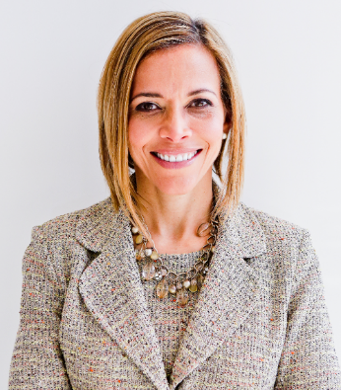  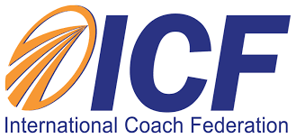 | Dr. Ginny Baro immigrated to the U.S. at age 14 with nothing more than a dream. Today, she is an award-winning international transformational speaker & leadership coach, career strategist, and #1 bestselling author of Healing Leadership and Fearless Women at Work. Named one of the Top 100 Global Thought Leaders, Dr. Baro has successfully delivered leadership training and coaching programs for Fortune 500 companies and keynotes impacting global audiences. She has been a leadership coach for McKinsey&Company's Hispanic/Latino Executive Leadership Program since 2021.  In 2020, Dr. Baro created the Fearless Leadership Mastermind™. Since then, the program has successfully helped talented female leaders in STEM fields, financial services, and Fortune 500 companies gain critical leadership skills to lead, engage, influence their teams, and advance in their roles. How? By design, it strategically leverages experiential, virtual mastermind circles within cohorts of up to 10 talented female peers for six months, executive group and individual coaching, mobile-friendly leadership training modules, personalized tools and assessments, accountability, community, and ongoing support for 12 months total.  She earned a Ph.D. in Information Systems, an MS in Computer Science, an MBA in Management, and a BA in Computer Science and Economics. She is a Certified Professional Coach (CPC) accredited by the International Coach Federation and is fluent in Spanish. To connect and learn more, please visit www.executivebound.com.

