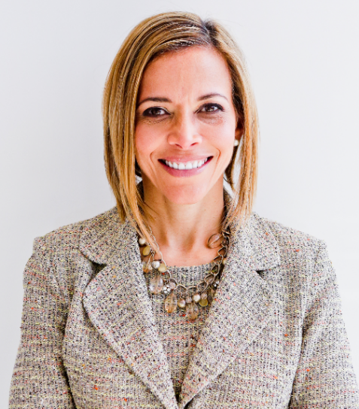 | Five Keys to Become Fearless at Work  with  Dr. Ginny A. Baro

Dear Women of Real Estate,
Welcome to your Training Resources! And congratulations on your commitment to growing professionally! It’s my pleasure to support you.
This is your dynamic Workbook to complement our training on November 2, 2022.
Please set aside 15 minutes to work on each of the tools. If you find it more enjoyable, enlist a trusted Women of RE peer to work on the exercises together.
You are empowered to prioritize and focus on your professional development. No one else can do this for us.
Use your Resources page until January ’23: http://www.ExecutiveBound.com/hola
Enjoy the journey and remember to contribute and lean on your community for support. We’re only an email away.
Live with purpose, live with joy!
Coach Ginny
DR. GINNY A. BARO, CEO, ExecutiveBound®

Workbook Table of Contents

1. YOUR UNIQUE VALUE PROPOSITION 3
2. KNOW THYSELF! 4
3. YOUR CENTERS OF INFLUENCE DIAGRAM 6
4. YOUR 12-MONTH GOALS AND ACTION PLAN 8
5. BET ON YOURSELF! 10

THIS WORKBOOK BELONGS TO:
Name: |  | Date:

YOUR UNIQUE VALUE PROPOSITION

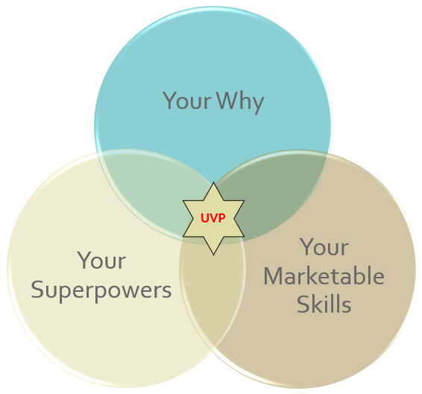 | Your Unique Value proposition (UVP) is at the core of your personal brand. Your UVP distinguishes you from other people who presumably perform the same role as you, and it is as unique as your fingerprints. How? It is a combination of these three components:  1. Your "Why," What is meaningful to you; 2. Your Superpowers--what you are great at and love; and 3. Your marketable skills, what you can get paid to do.  Knowing your UVP will help you: 1) Boost your confidence, 2) Position yourself to add the most value, 3) Guide career and life decisions, 4) Influence and collaborate with your network and Centers of Influence.

- Your WHY: What do you live for? What fuels your goals? What is meaningful for you?

- Your Superpowers: What are you great at? What makes you special? What brings you joy?

- Your Marketable Skills: What are you great at? What makes you special? What brings you joy?

2. YOUR 12-MONTH GOALS AND ACTION PLAN
Imagine you and I are meeting 12 months from now, and you’ve had a WILDLY SUCCESSFUL YEAR—the best of your career yet! What happened? Share with me in detail what you achieved, how you showed up, how you felt, what you and the team accomplished, what happened in your personal life, the impacts you had, and how you contributed. Highlight why these outcomes are important, a timeframe to accomplish them, and the resources—people, places, and organizations—that can help to accelerate your results. Focus on the outcomes and goals that will have the most significant positive impact for you across all areas of the Wheel of Life (i.e., career, finances, family & friends, romantic relationships, fun & recreation, health/wellness, personal growth/spirituality, physical environment).

DESIRED RESULT / OUTCOME / GOAL | PURPOSE, WHY IS THIS IMPORTANT? | ACTIONS & ACTIVITIES TO PURSUE IT | COMPLETION TIMEFRAME | OTHER RESOURCES

YOUR CENTERS OF INFLUENCE DIAGRAM
Use this tool to identify your “Centers of Influence” in your professional world. Engage with them proactively and connect with them periodically and intentionally. Shift from being “transactional” to being “relational” and you’ll expand your “army of allies,” support network and advocates.
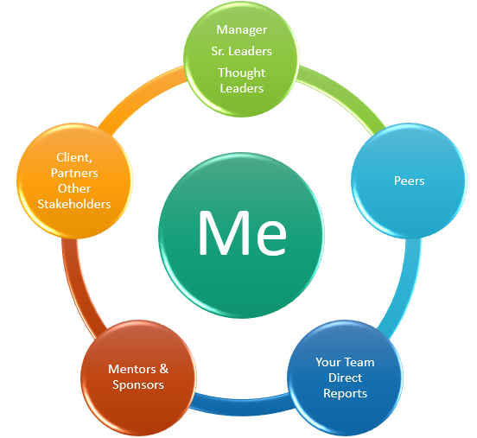
- Using the above diagram as a guide, use the next page to draw your personalized Centers of Influence diagram using the names or person’s initials that belong in each circle.
Manager, Sr. Leaders, Thought Leaders | Include your manager and other senior leaders in the organization connected to your function or who you can learn from about the business, how it runs, the vision, etc.
Your Peers | Who are your peers within your team or those in other departments with whom you interact? Having them in your corner is meaningful.
Your Team | Who are your direct reports, or others significant stakeholders at this level of the organization who support your team? (e.g., any matrix reporting teams)
Mentors / Sponsors | Who are your mentors? They serve as advisors; you trust their guidance and direction, and they can make introductions to others in the company or industry, for example. Who are your sponsors? These senior leaders can assign you an initiative, advocate for your promotion into a new role, and make it happen.
Other Stakeholders | List any critical people who are influencers in the organization or outside who interface with your role. They can be your advocates or promote your good work to others based on how they know you.

Draw your Centers of Influence diagram below. Notice how they form a “ring” of protection—your army of allies:

- What did you notice as you built your diagram?
- Did you find any “gaps” in one or more areas? Which ones?
- How healthy are your sponsor & mentor relationships? Who do you admire / appreciate as a leader / are curious about? Those could become mentors / sponsors.
- Who do you know who can support you in developing those relationships?
- What ideas come to mind when considering connecting with the people on your diagram? Jot them down here.
- Pick one or two people to connect with weekly, monthly, or quarterly.
- Mark your calendar to reach out to them and set up a 15-minute live or cyber-coffee or tea. Slow and steady wins the race. Be fearless (act despite the fear).

KNOW THYSELF!
Use this tool to uncover the stories, fears, and beliefs which are currently holding you back and those that give you courage.
- What currently holds you back? Notice what components are “external” and which are “internal.”
- What recurring beliefs or stories do you keep telling yourself about yourself? Does the narrative or your beliefs and stories serve your career and life’s vision? Does it empower you? How would you reframe or rewrite them to empower and inspire you to step outside of your comfort zone and live your Why?
- If you're honest with yourself, what fears come up when you think about your future as a leader in your career, business, and life by reaching for something outside of your comfort zone? What is possible on the other side of your fears? Consider what you’re giving up by staying in your comfort zone, evaluating if the cost is worth it to you: E.g.
Fear of rejection | Fear of losing love | Fear of being overwhelmed
Fear of criticism | Fear of success | Fear of making a mistake
Fear of failure | Fear of being exposed | Fear of what others will think of you

5. BET ON YOURSELF!
Let’s clarify the new attitude, mindset, and actions that will support you in becoming fearless at work, pursuing your vision and goals unapologetically. Trust the process. Know that it takes time—be patient. Above all, believe in your value, keep learning, and don’t compare yourself to others. You’re unique, magnificent, and here to share your gifts with the rest of us. Don’t hold back! A tribe of sisters has your back!
- What actions will bring your vision & goals to reality?
- How fulfilling will it feel?
- What challenges do you anticipate?
- How will you celebrate and enjoy the fruits of your hard work?

JOIN OUR COMMUNITY TO GAIN VALUABLE resources, strategies, AND TOOLS to help you REACH YOUR FULL POTENTIAL AND next level IN CAREER AND LIFE at www.executivebound.com
ABOUT DR. GINNY A. BARO, PHD, MBA, MS, CPC, CEO, FOUNDER AT EXECUTIVEBOUND

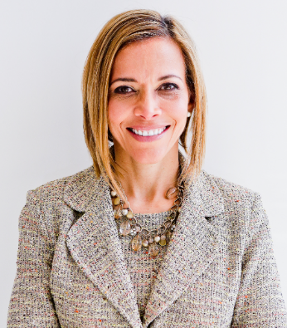  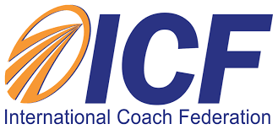  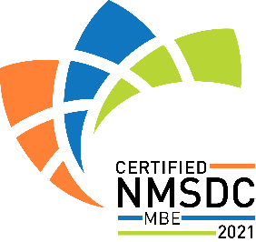 | Dr. Ginny Baro immigrated to the U.S. at age 14 with nothing more than a dream. Today, she is an award-winning international transformational speaker & leadership coach, career strategist, and #1 bestselling author of Healing Leadership and Fearless Women at Work. Named one of the Top 100 Global Thought Leaders, Dr. Baro has successfully delivered leadership training and coaching programs for Fortune 500 companies and keynotes impacting global audiences. She has been a leadership coach for McKinsey&Company's Hispanic/Latino Executive Leadership Program since 2021.  In 2020, Dr. Baro created the Fearless Leadership Mastermind™. Since then, the program has successfully helped talented female leaders in STEM fields, financial services, and Fortune 500 companies gain critical leadership skills to lead, engage, influence their teams, and advance in their roles. How? By design, it strategically leverages experiential, virtual mastermind circles within cohorts of up to 10 talented female peers for six months, executive group and individual coaching, mobile-friendly leadership training modules, personalized tools and assessments, accountability, community, and ongoing support for 12 months total.  She earned a Ph.D. in Information Systems, an MS in Computer Science, an MBA in Management, and a BA in Computer Science and Economics. She is a Certified Professional Coach (CPC) accredited by the International Coach Federation and is fluent in Spanish. To connect and learn more, please visit www.executivebound.com.

