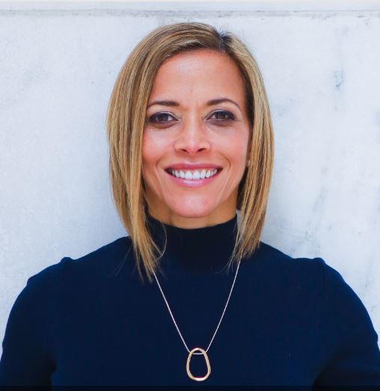

Thoughtful Leadership Certification Celebration
with
Dr. Ginny A. Baro

Dear Thoughtful Leader,

Congratulations on your most recent achievement, the Thoughtful Leadership Certification at the Gabelli School of Business, and your commitment to rising to your leadership potential.

These exercises and resources will support you in getting clear on your 12-month compelling vision and staying focused, especially during challenging times, with the exact steps that will help you move forward confidently.

All your efforts and time investment will result in a roadmap that will support you in taking action fearlessly, acting despite the fear as you pursue the outcomes you envision. And to stay in momentum to tap into your full potential as the leader you are meant to be.

You will have access to your private page until June 29, 2022 (www.ExecutiveBound.com/tlc). Take advantage of this opportunity and tools to create a big enough vision for your future and create a clear, actionable plan that meets your specific goals and needs. Lean on your community of peers for support along the way.

Knowledge and execution are power! Congrats again! You got this! We believe in you.

Live with purpose, live with joy!
Coach Ginny
DR. GINNY A. BARO, CEO, ExecutiveBound®

WORKBOOK TABLE OF CONTENTS

YOUR ROADMAP AND ACTION PLAN 2
STAYING FOCUSED 4

THIS WORKBOOK BELONGS TO:
Name: |  | Date:

YOUR ROADMAP AND ACTION PLAN
Knowledge and execution are power! Let’s identify YOUR ROADMAP, the actionable steps YOU will take to get to your next level in career and life, make progress, stay in momentum, and make the positive changes you seek. This is VERY IMPORTANT. Imagine 12 months from now, you had a wildly successful year, what happened? List the outcomes you want (goals). Capture why each goal is important to you—this becomes the fuel to pursue them. Identify the resources you will need to get it done. Consider the activities to leverage your strengths and opportunities and mitigate any risks. Set realistic expectations. Biting off too much or setting timelines that you cannot commit to could sabotage your efforts. Imagine how great you’ll feel when you achieve these goals—your compelling future, or if you do not achieve them—your painful future. This document is dynamic—review it, tweak it, and track your progress along the way. Surround yourself with people who will encourage and support you when you get stuck.

Name: | Date:
DESIRED RESULT / OUTCOME / GOAL  (COMPELLING VISION) | PURPOSE, WHY IS THIS IMPORTANT? | ACTIONS & ACTIVITIES TO PURSUE IT | COMPLETION TIMEFRAME | RESOURCES TO GET IT DONE

EXAMPLE: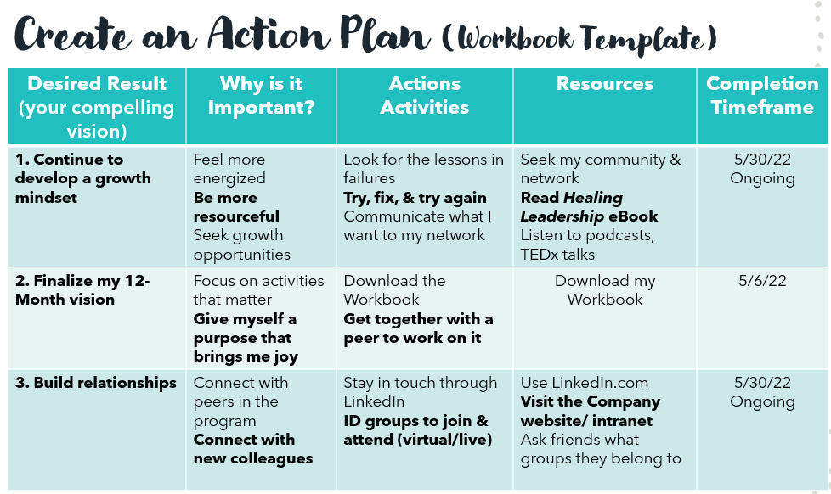

STAYING FOCUSED
Use this tool when you need to focus on a specific goal. Instead of worrying about things which are not important to you or those you can’t control, apply these strategies to feel the most empowered and maximize your contributions and resources, your energy, time, efforts.

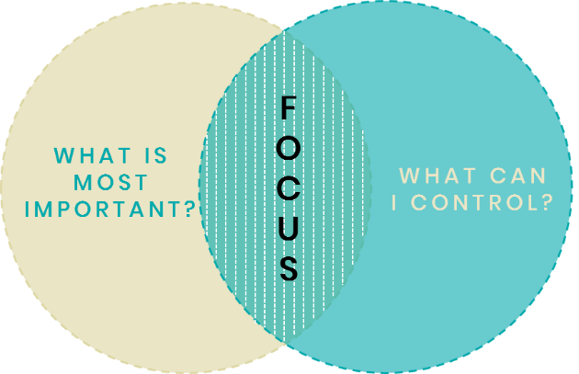
- In the context of a goal (be specific), what’s important and what can you control? This will be your focus.

- Based on what you discovered, what actions will you focus on that will create maximum results and best outcomes?

- What do you plan to do when you hit a roadblock (a fear or a limiting belief) that could make you lose certainty and motivation, or make you feel like procrastinating, or (fill in the blank based on what you’ve experienced tends to hold you back)? Get clear and create a support/backup plan.

- How do you plan to support others and stay connected with an empowering community that will support your well-being and goals?

Join our community to gain valuable resources, strategies, and tools that will help you reach your full potential and next level in career and life at www.executivebound.com.
ABOUT DR. GINNY A. BARO, MBA, MS, CPC

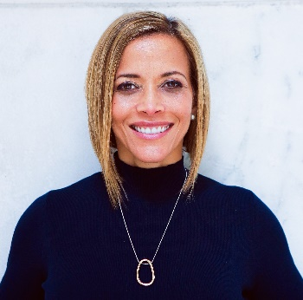  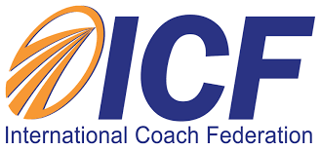  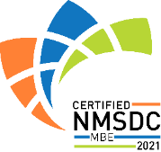 | Dr. Ginny A. Baro immigrated to the U.S. at age 14 with nothing more than a dream. Today, she is an award-winning international transformational speaker & leadership coach, career strategist, and #1 bestselling author of Healing Leadership and Fearless Women at Work. Named one of the Top 100 Global Thought Leaders, Dr. Baro has successfully delivered leadership training and coaching programs for Fortune 500 companies and keynotes impacting global audiences. She earned a Ph.D. in Information Systems, an MS in Computer Science, an MBA in Management, and a BA in Computer Science and Economics. She is a Certified Professional Coach (CPC) accredited by the International Coach Federation and is fluent in Spanish.  Dr. Baro founded ExecutiveBound® in 2017 and develops senior leaders to create inclusive workplaces that promote business growth, high-performing teams, and personal well-being. In 2020, she launched the Fearless Leadership Mastermind™ program, establishing a new gold standard, turnkey leadership development solution for organizations. The program has successfully helped female leaders in STEM fields, financial services, and Fortune 500 companies gain critical leadership skills to lead, engage, influence their teams, and ascend in their roles. To connect and learn more, please visit www.executivebound.com.

